

**EE314 – Mini-Project**

**Task B: Filter & Decimator**

**Group 8**

**GROUP: Group B DATE: 21/04/2023**

*I declare that I have not plagiarised or excessively quoted the work of others, nor have I colluded*

*with others to represent collaborative work as my own. I have appropriately cited all information*

*derived from the published and unpublished work of other and less than 5% of my submission*

*quotes the source material directly.*

**NAME: Patrick Kavanagh SIGNED: ________________________________**

**NAME: Alessandro Lupo SIGNED: ________________________________**

**NAME: James Petri SIGNED: ________________________________**

**NAME: ________________________________ SIGNED: ________________________________**

# Project Completion Plan:

|  |  |  |
| --- | --- | --- |
| Tasks | Description | Name |
| Research | The functionality of a decimator and the best way of implementing the decimator where researched. As well as how the decimator is used in industry in conjunction with filters. | Alessandro Lupo  Patrick Kavanagh  James Petri |
| Module Coding | A module was created to implement the functionality of the filter and of the decimator. The first step to achieve this was to implement the second order low pass function. Secondly the average of the last 64 outputs of the filter results. The last step is to down sample the data by selecting one sample every 64 samples. | Alessandro Lupo  Patrick Kavanagh  James Petri |
| Testbench Coding | The testbench was created to test the full functionality of the module. Different data streams where passed though the module to test a broad range of values to show the ability of the module to work with different values. Edge cases where also tested. All the possible data streams couldn’t be tested for as it would take to much time. | Alessandro Lupo  Patrick Kavanagh  James Petri |

# Introduction (~ 1 page):

## Block Diagram

DUT

in

IN

8

Decimator

out

rst

OUT

RST

CLK

Filter.v

Filter_TB.v

clk

## Description of the use of such a module in everyday systems

Decimation is a signal processing technique that is commonly used in a wide range of applications. Its primary purpose is to reduce the sampling rate of a signal while retaining its essential information. This is achieved by eliminating the unnecessary data points from the signal that fall outside of the frequency range of interest, resulting in a lower sampling frequency.

The technique is particularly useful when the Nyquist frequency of a signal is much higher than the highest frequency component present in the signal. By removing these extraneous data points, decimation can significantly reduce the amount of data that needs to be processed, thereby decreasing the computational power required to analyse the signal. Additionally, decimators can improve the signal to noise ratio by filtering out unwanted noise present in the signal.

Another advantage of decimation is its ability to save memory or storage space. This can be critical in applications that involve large amounts of data, such as audio or video processing, where reducing the sampling rate of the signal can significantly decrease the amount of storage required. Furthermore, decimation can also help to mitigate aliasing effects that may occur when the signal is under sampled, resulting in a more accurate representation of the original signal. Overall, decimation is a powerful tool in signal processing that can improve the efficiency and accuracy of a wide range of applications.

# Verilog Testbench (with Comments):

Code + Comments

# Verilog Module(s) (with Comments):

Code + Comments

# Description of the Design

The best way to describe the functionality of the design is to break it up into steps.

Filtering with a second-order low pass function: The input data stream is first passed through a second-order low pass filter with a transfer function of ${\left(1-Z^{-1}\right)}^{2}$. This filter is designed to remove high-frequency noise and other unwanted signals from the audio data.

Running average calculation: The output of the filter is then used to calculate a running average of the past 64 filter outputs. This step helps to smooth out any remaining noise or irregularities in the signal.

Down-sampling to 44 kHz: The processed data is then down-sampled by selecting one sample out of every 64 samples. This step reduces the data rate and helps to further simplify the signal processing chain.

The final step involves generating an 8-bit output signal. The output signal is represented using 8 bits, which allows for a wide range of amplitude levels.

# Simulated Results

Indicate examples or sections of signals from a testbench simulation which clearly demonstrate the module(s) work as expected.

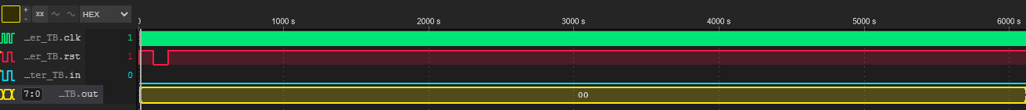

The reset is run and the output remains 0 as the first input is a data stream with inputs of only zeros

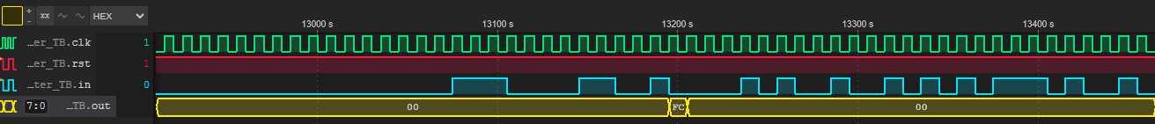252 in decimal (FC) is the output here as it’s the average of the past 64 inputs after being down sampled by 64

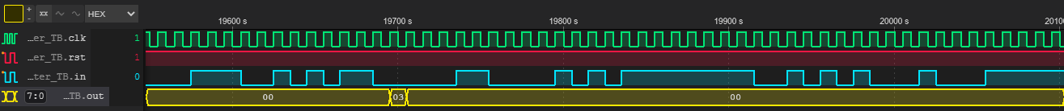 In this case the average of the last 64 inputs was 3 after being down sampled by 64

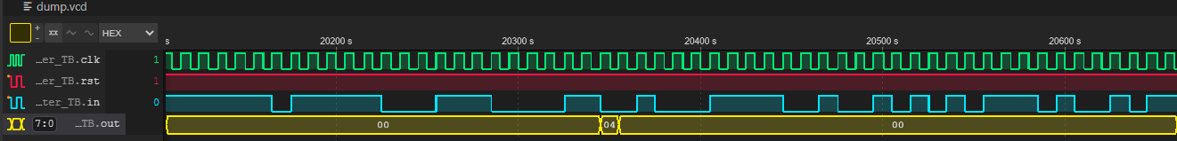

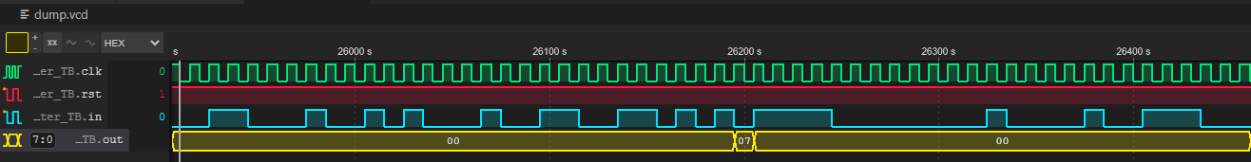

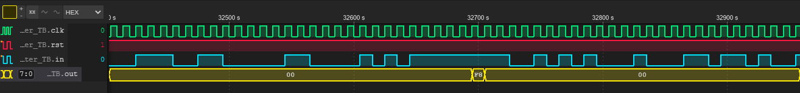

# Conclusions

## Explain in words how you validated that the design works correctly, and how it is possible to tell that it works.

Manual calculations were performed with the given inputs and checked to see if the outputs matched.

## What additional features if any did you incorporate into the design or testbench to improve it?

Edge cases were added to the testbench.

## What are the limitations of your design?

The input needs to be 1 bit, so larger inputs cannot be passed through at once. It can only take in one data stream at a time